**AST Intranet System**

**Company Wall**

|  |  |  |  |
| --- | --- | --- | --- |
| **Advanced Sys-Tek Pvt. Ltd.**  (Short desc, image and website link) | | | |
| **AST Environment Solution**  (Short desc, image and website link) | | **Terranomous**  (Short desc, image and website link) | |
| **Important Announcement**  (Recent order received or any awards received) | | | |
| **Birthday Wishes** | | **Work Anniversary** | |
| **Orders Received**  Just numbers | | **Order Received Values**  Just numbers | |
| **E-resource**  Short Desc  Direct link | **Spine HR**  Short Desc  Direct link | **CIM**  Short Desc  Direct link | **CRR**  Short Desc  Direct link |
| **Induction Manual**  (One line description and preview link) | | **Exit Manual**  (One line description and preview link) | |
| **Policies**  (Opens a page where all the policies listed down) | | | |
| **New Joinee Information**  (Information remains only for a week) | | | |
| **Cafeteria Menu for the week** | | **Holiday Calendar for the year** | |
| **Active Employee Count** | | | |
| **Link to Pictures of the last event taken place along with a one liner description** | | | |
| **Upcoming Events (One line Description)** | | | |

**Teams/Departments**

|  |  |  |
| --- | --- | --- |
| **Software**  (Short Description of the dept,  When clicked on list of team members become visible) | **Customer Service**  (Short Description of the dept,  When clicked on list of team members become visible) | **HR**  (Short Description of the dept,  When clicked on list of team members become visible) |
| **Plant Operations**  (Short Description of the dept,  When clicked on list of team members become visible) | **Finance & Accounts**  (Short Description of the dept,  When clicked on list of team members become visible) | **Sales & Proposals**  (Short Description of the dept,  When clicked on list of team members become visible) |
| **Business Development**  (Short Description of the dept,  When clicked on list of team members become visible) | **Projects**  (Short Description of the dept,  When clicked on list of team members become visible) | **Engineering & Operations**  (Short Description of the dept,  When clicked on list of team members become visible) |

**Employee List**

List of all employees with relevant information (same as that shown in CIM)

**Policies**

List of Policies along with their documents.

1. Inter department Transfer policy
2. Employee Referral Policy
3. Overseas Travel Policy
4. Outstation Travel Policy
5. IT Policy
6. Induct Policy
7. Exit Policy

**Town Hall**

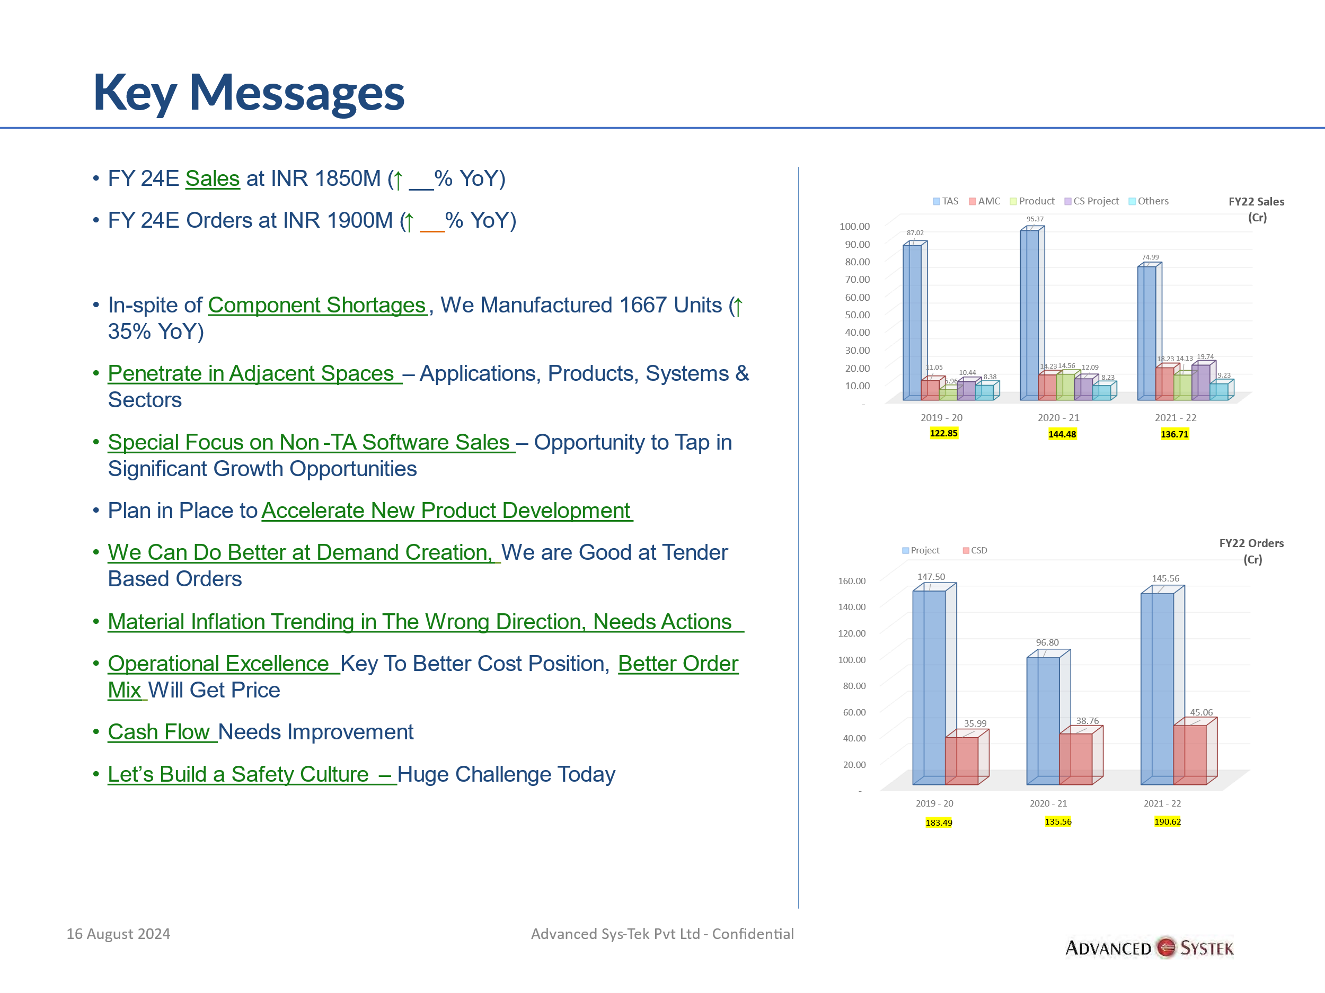

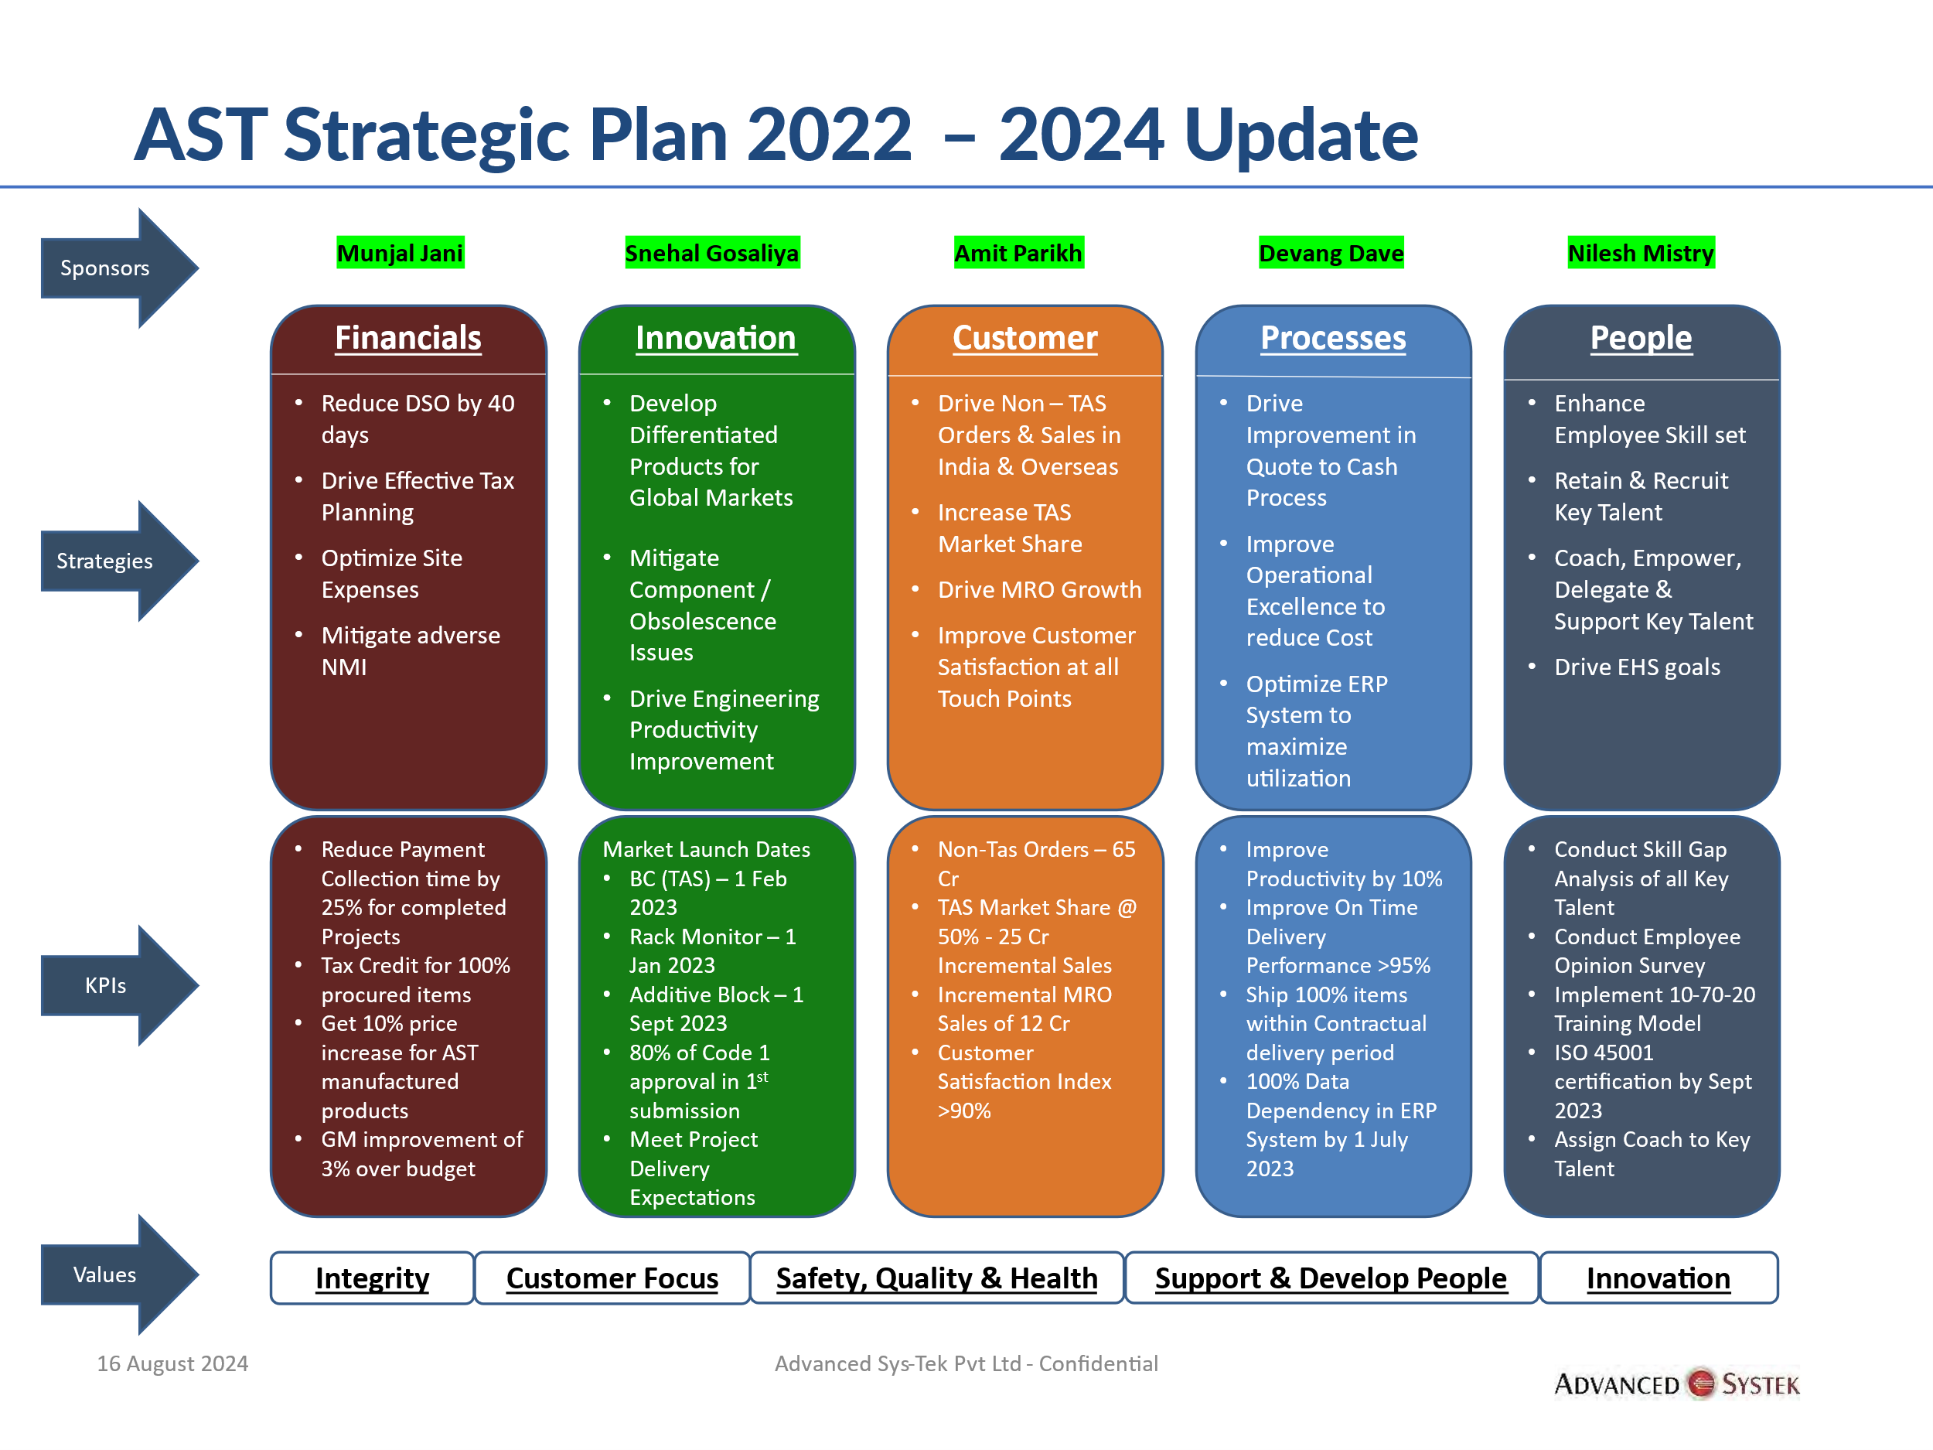

**Resources**

List of Resources, in terms of free to use software, tools, applications, company logo, templates, Power point presentation, email signatures, certificates etc.

**Files**

Department wise access to File server folders

|  |  |  |
| --- | --- | --- |
| **Software**  (Short Description of the dept,  When clicked on list of team members become visible) | **Customer Service**  (Short Description of the dept,  When clicked on list of team members become visible) | **HR**  (Short Description of the dept,  When clicked on list of team members become visible) |
| **Plant Operations**  (Short Description of the dept,  When clicked on list of team members become visible) | **Finance & Accounts**  (Short Description of the dept,  When clicked on list of team members become visible) | **Sales & Proposals**  (Short Description of the dept,  When clicked on list of team members become visible) |
| **Business Development**  (Short Description of the dept,  When clicked on list of team members become visible) | **Projects**  (Short Description of the dept,  When clicked on list of team members become visible) | **Engineering & Operations**  (Short Description of the dept,  When clicked on list of team members become visible) |

**Manuals**

|  |  |  |
| --- | --- | --- |
| **CIM**  (List of related manuals) | **CRR**  (List of related manuals) | **E-resource**  (List of related manuals) |
| **Spine HR - Expense**  (List of related manuals) | **Spine HR - Timesheet**  (List of related manuals) | **Spine HR – Payroll**  (List of related manuals) |
| **Product manuals**  (List of related manuals) | **Others**  (List of related manuals) |  |

**Recognition/Achievements (company and employees)**

Company and Employees Rewards and its achievements

**Events**

Upcoming events of company